CS 1358 Introduction to Programming in Python

Fall Semester 2019

Prof. Pai H. Chou

Self-Check 3

Due Date: Sunday, September 29, 2019, 11:59pm

Answer the following questions to check your understanding of your material. Expect the same kind of questions to show up on your tests.

## 1. Definitions and Short Answers

1. When you call the function ord('A') it returns 65. What does it mean?
   * A’s ASCII code is 65.
   * 搜尋符號(char)A，對應的編碼(code)為65。
2. What is the value of chr(70)? (based on the knowledge of the previous question)
   * F
   * 搜尋編碼(code)70，對應的符號(char)為F。
3. What is the difference between **ASCII** character set and **Unicode**?
   * ASCII code 只有英文 & 基本符號；Unicode擴展到多國語言
   * ASCII character以英文為主(由美國最早標準化)；Unicode則集合了注音符號、漢字、撲克牌花色等。

If a character is in ASCII, is it also in Unicode?

* + 在ASCII裡有的，Unicode就會有
  + Yes! Unicode整合了ASCII。

Are there characters in Unicode that are not in ASCII?

* + 有，e.g. 中文
  + Yes! e.g.注音符號、漢字、撲克牌花色...

1. How is **newline** (also known as a **line feed**) represented as a string literal? In other words, how do you print a newline?
   * print(‘\n’)
   * print(‘\x10')
2. What is a **carriage return**? What is its string literal, and what effect does it have when printed?
   * cursor 調到最左邊
   * ‘\r’ or ‘\x08’
3. From the command line, what keys do you type to **kill** a running Python program?
   * Ctrl + C
4. Give an example of a **string literal** for McDonald's
   * “McDonald’s”
5. Give an example of an **integer literal**
   * 12  
     (正負整數，可用不同進位表示)
6. Give an example of a **floating point literal**
   * 12.3  
     (正負小數，可用科學記號表示)
7. What is the difference between print(hello) and print("hello")?
   * print(hello) ：print value of thr string literal ‘hello’
   * print("hello") ： print the string literal  
     前者會印出先前被assigned的值(非字面值)；後者會印出字串hello。

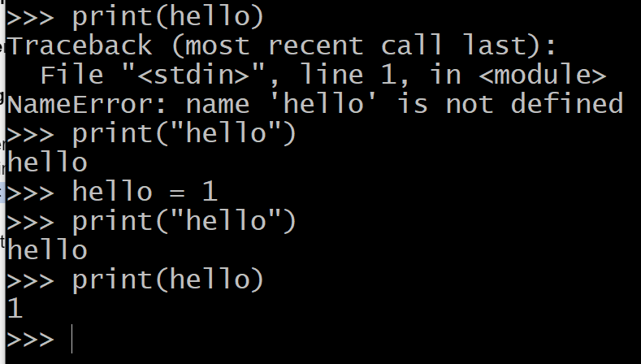

1. What is a **numeral**? What is the difference between a numeral and a **number**?
   * numeral 書寫表達的方式，a notation for number
   * number: the numerc quantity(是數值，例如n=123，解讀為一百二十三)
   * numeral: a notation for number(是number的表示方法，例如n=123，是用char(49), char(50), char(51)呈現出來的)
2. What is the **value** of the integer literal 0b101? Express your answer in base-10 or in English.
   * 5 five
3. What is the **octal literal** for the integer value 10?
   * 0o12
4. What is the **value** of the integer literal 0x12? Express your answer in base-10 or in English.
   * 18 eighteen
5. What is the return **value** of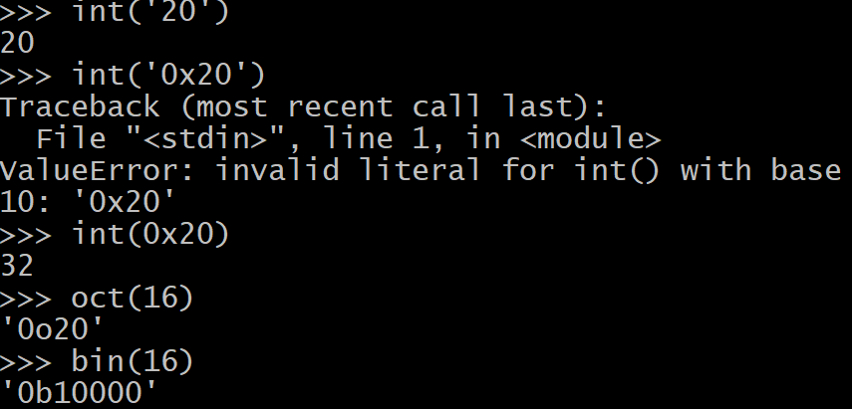
   * int('20')
     1. 20
   * int('0x20')
     1. error
   * oct(16)
     1. ‘0o20’
   * bin(16)
     1. ‘0b10000’
6. What is the value of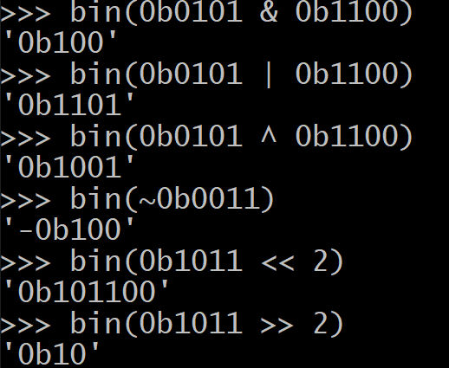
   * 0b0101 & 0b1100
     1. 0b100
   * 0b0101 | 0b1100
     1. 0b1101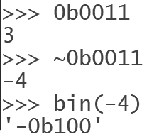
   * 0b0101 ^ 0b1100
     1. 0b1001
   * ~0b0011
     1. ~~0b1100~~
     2. -0b100
   * 0b1011 << 2
     1. 0b101100
   * 0b1011 >> 2
     1. ~~0b111011~~
     2. 0b10

write your answers as binary literals

1. What are two possible values of the bool class?
   * True, False
2. What is the value of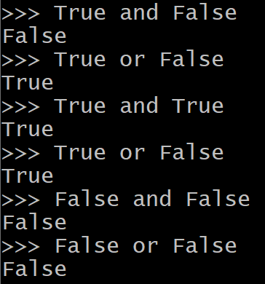
   * True and False
     1. False
   * True or False
     1. True
   * True and True
     1. True
   * True or False
     1. True
   * False and False
     1. False
   * False or False
     1. False
3. What is the value of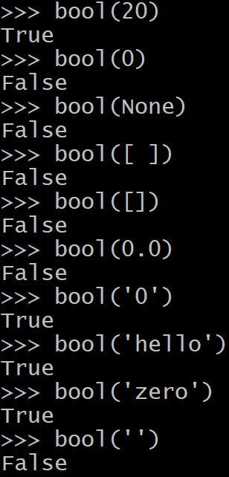
   * bool(20)
     1. True
   * bool(0)
     1. False
   * bool(None)
     1. False
   * bool([ ])
     1. False
   * bool([])
     1. False
   * bool(0.0)
     1. False
   * bool('0')
     1. True
   * bool('hello')
     1. True
   * bool('zero')
     1. True
   * bool('')
     1. False
   * bool(' ')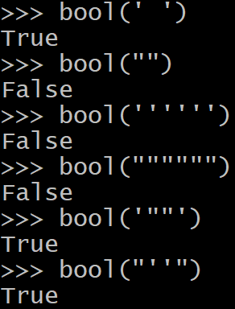
     1. True
   * bool("")
     1. False
   * bool('''''')
     1. False
   * bool("""""")
     1. False
   * bool('""')
     1. True
   * bool("''")
     1. True
4. What is the value of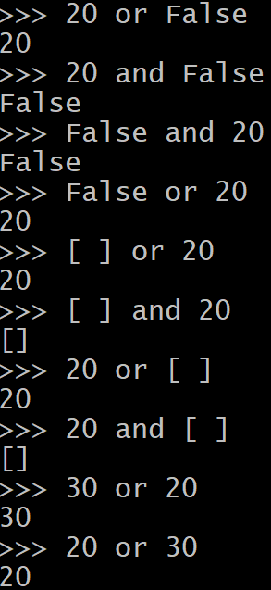
   * 20 or False
     1. 20
   * 20 and False
     1. False
   * False and 20
     1. False
   * False or 20
     1. 20
   * [ ] or 20
     1. 20
   * [ ] and 20
     1. [ ]
   * 20 or [ ]
     1. 20
   * 20 and [ ]
     1. [ ]
   * 30 or 20
     1. 30
   * 20 or 30
     1. 20
5. Assume x = 3 and y = 2, what is the value of 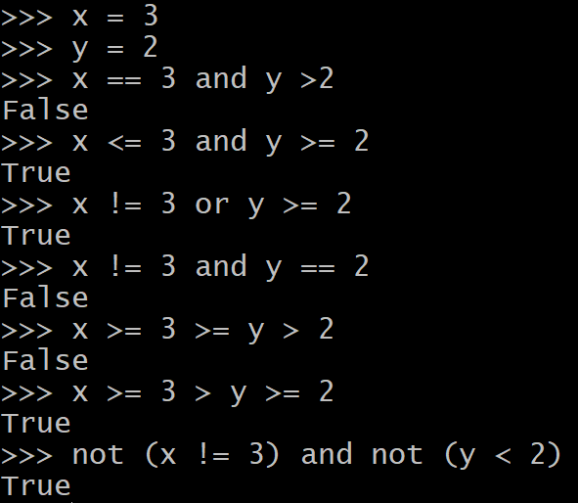
   * x == 3 and y > 2
     1. False
   * x <= 3 and y >= 2
     1. True
   * x != 3 or y >= 2
     1. True
   * x != 3 and y == 2
     1. False
   * x >= 3 >= y > 2
     1. False
   * x >= 3 > y >= 2
     1. True
   * not (x != 3) and not (y < 2)
     1. True
6. What is the value of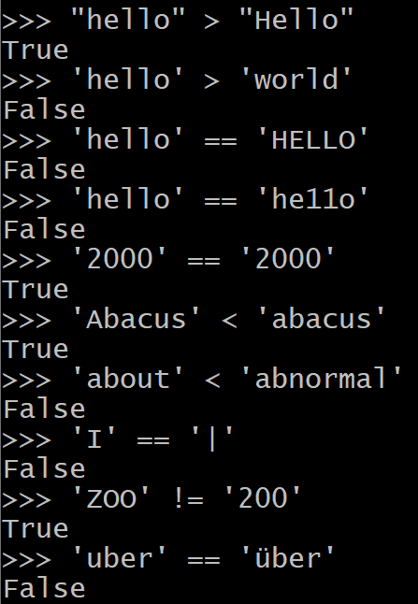
   * "hello" > "Hello"
     1. True
   * 'hello' > 'world'
     1. False
   * 'hello' == 'HELLO'
     1. False
   * 'hello' == 'he11o'
     1. False
   * '2000' == '2OOO'
     1. True
   * 'Abacus' < 'abacus'
     1. True
   * 'about' < 'abnormal'
     1. False
   * 'I' == '|'
     1. Fa;se
   * 'ZOO' != '200'
     1. True
   * 'uber' == 'über'
     1. False
   * 'naive' == 'naïve'
     1. False
   * 'Dijkstra' == 'Dĳkstra'
     1. False
7. What is the meaning of **lexicographical order**?
   * dictionary order, but case sensitive.
   * 如同字典排序方式，但有區分大小寫。
8. What is the **data type** of 2+3j? What is the meaning of 3j?
   * complex
   * 3j = 虛數部分為 3